27.39: a) 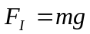 when bar is just ready to levitate.

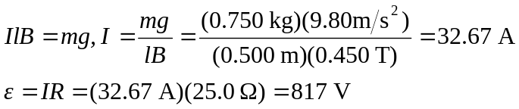

b)
